***MIDTERM EXAM***

***Student Name: Basavraj Nagappa Jaliminche***

***Student Id: 8800149***

***PROGRAM: Reporting Systems and Database Development (1517)***

***Course Name: Relational Databases PROG 8590***

**Q.1. Write a query that list the AddressID, AddressLine1, AddressLine2, and City of the persons without any null values in their AddressLine2. **Sort your query by the column city.**

**Query:**

SELECT AddressID,AddressLine1,AddressLine2,City--Selecting columns

FROM [Person].[Address]--from table

WHERE AddressLine2 IS NOT NULL --condition for not having null values

ORDER BY City-- ordering by city name

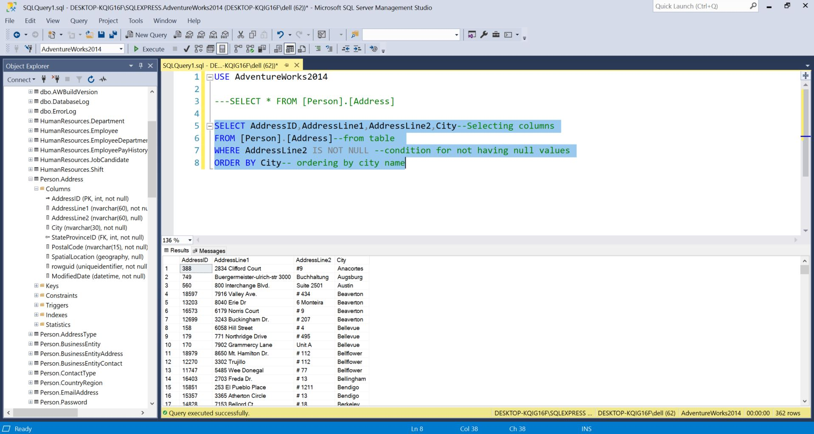

**QUESTION 1**

**Q.2 Write a query to list all persons with a first name not starting with a vowel.**

**Query:**

SELECT DISTINCT [FirstName]--SELECTING THE FISTNAME FOR NO DUPLICATION USEING DISTINCT

FROM [Person].[Person]--NAME OF TABLE

WHERE FirstName NOT LIKE '[a,e,i,o,u]%'--CONDITION FOR NAME NOT STARTING WITH VOVEL

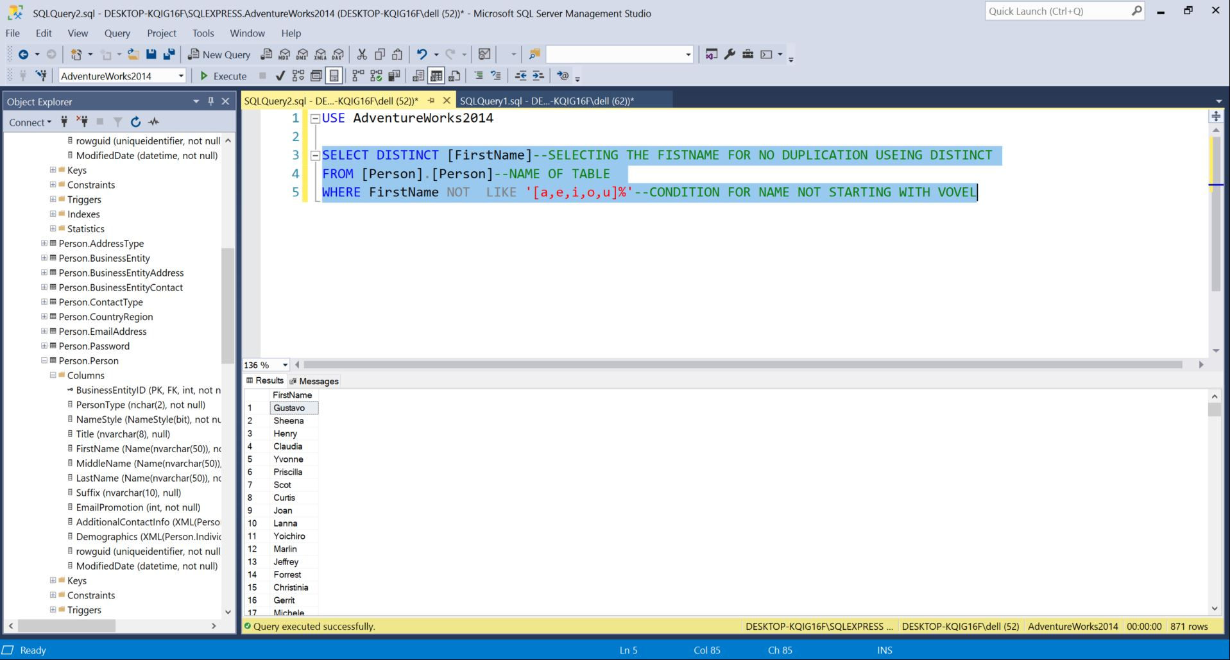

**QUESTION 2**

**Q.3 Write a query that list the Name, ProductReviewID and Color of each product that has a review and is not of the color Multi or Yellow. [5 pts] ** Use the appropriate SQL JOINS ** Use Alias for the tables**.

**Query:**

SELECT pp.Name as 'Name',PPR.ProductReviewID 'Review ID',pp.Color--DISPLAYING THE RESULTS WITH ALIAS NAMES

FROM [Production].[Product] PP --TABLE NAME

INNER JOIN [Production].[ProductReview] PPR ---WE HAVE USED INNER JOIN

ON PP.ProductID = PPR.ProductID ---lINK BETWEEN THE TABLES

WHERE PP.Color NOT IN ('Multi','Yellow')---CONDITIONS FOR THE COLOURS

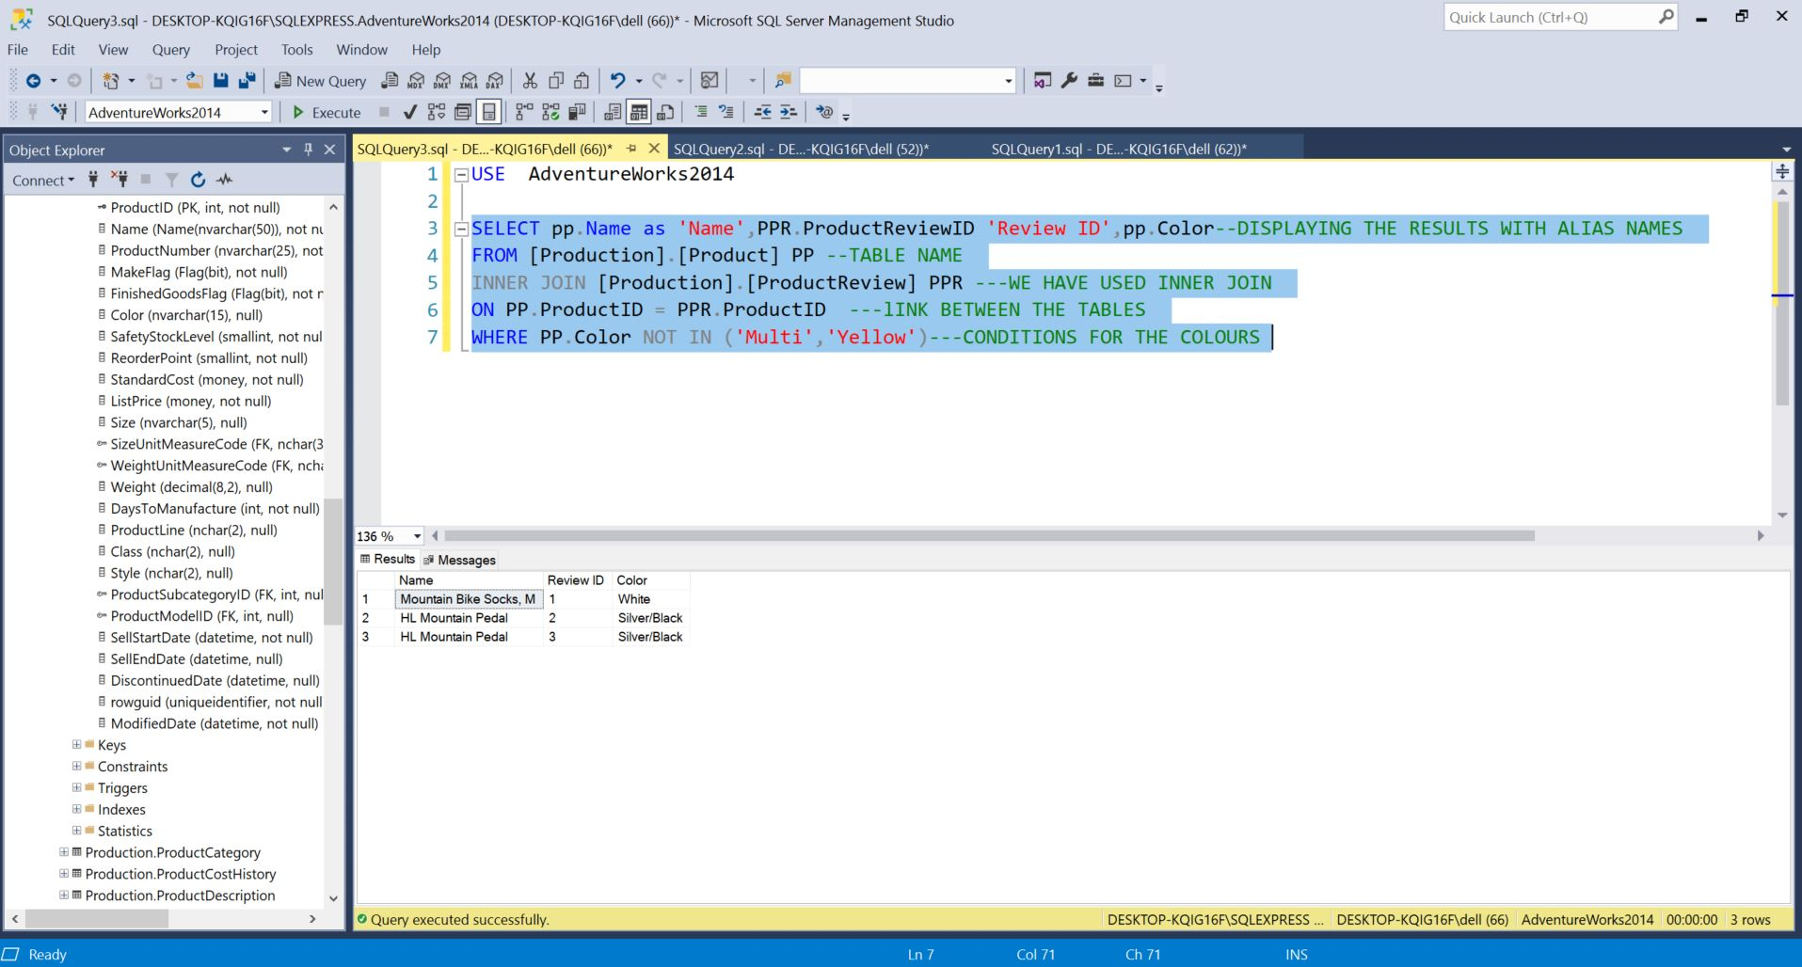

**QUESTION 3**

**Q.4 Write a query that will return the FirstName, LastName,Title, BusinessEntityID, and NationalIDNumber of all the employees in the company. [4 pts] ** Hint: Your query should return 290 rows. ** Mangae the NULL values when returning the Full Name of the employees.**

**Query:**

SET CONCAT_NULL_YIELDS_NULL OFF ---MANAGING NULL VALUES

SELECT PP.[Title]+''+PP.FirstName+ ''+PP.LastName +'' AS [FULLNAME] ,PP.BusinessEntityID,HRE.NationalIDNumber--ALISING

--NAMES AND CONCAT THEM WITH FULL NAME AND DISPLAYING RESULTS

FROM [Person].[Person] PP

INNER JOIN [HumanResources].[Employee] HRE --JOINING THE TWO TABLES WITH INNER JOIN

ON PP.[BusinessEntityID] = HRE.[BusinessEntityID]--LINK BETWEEN TWO TABLES

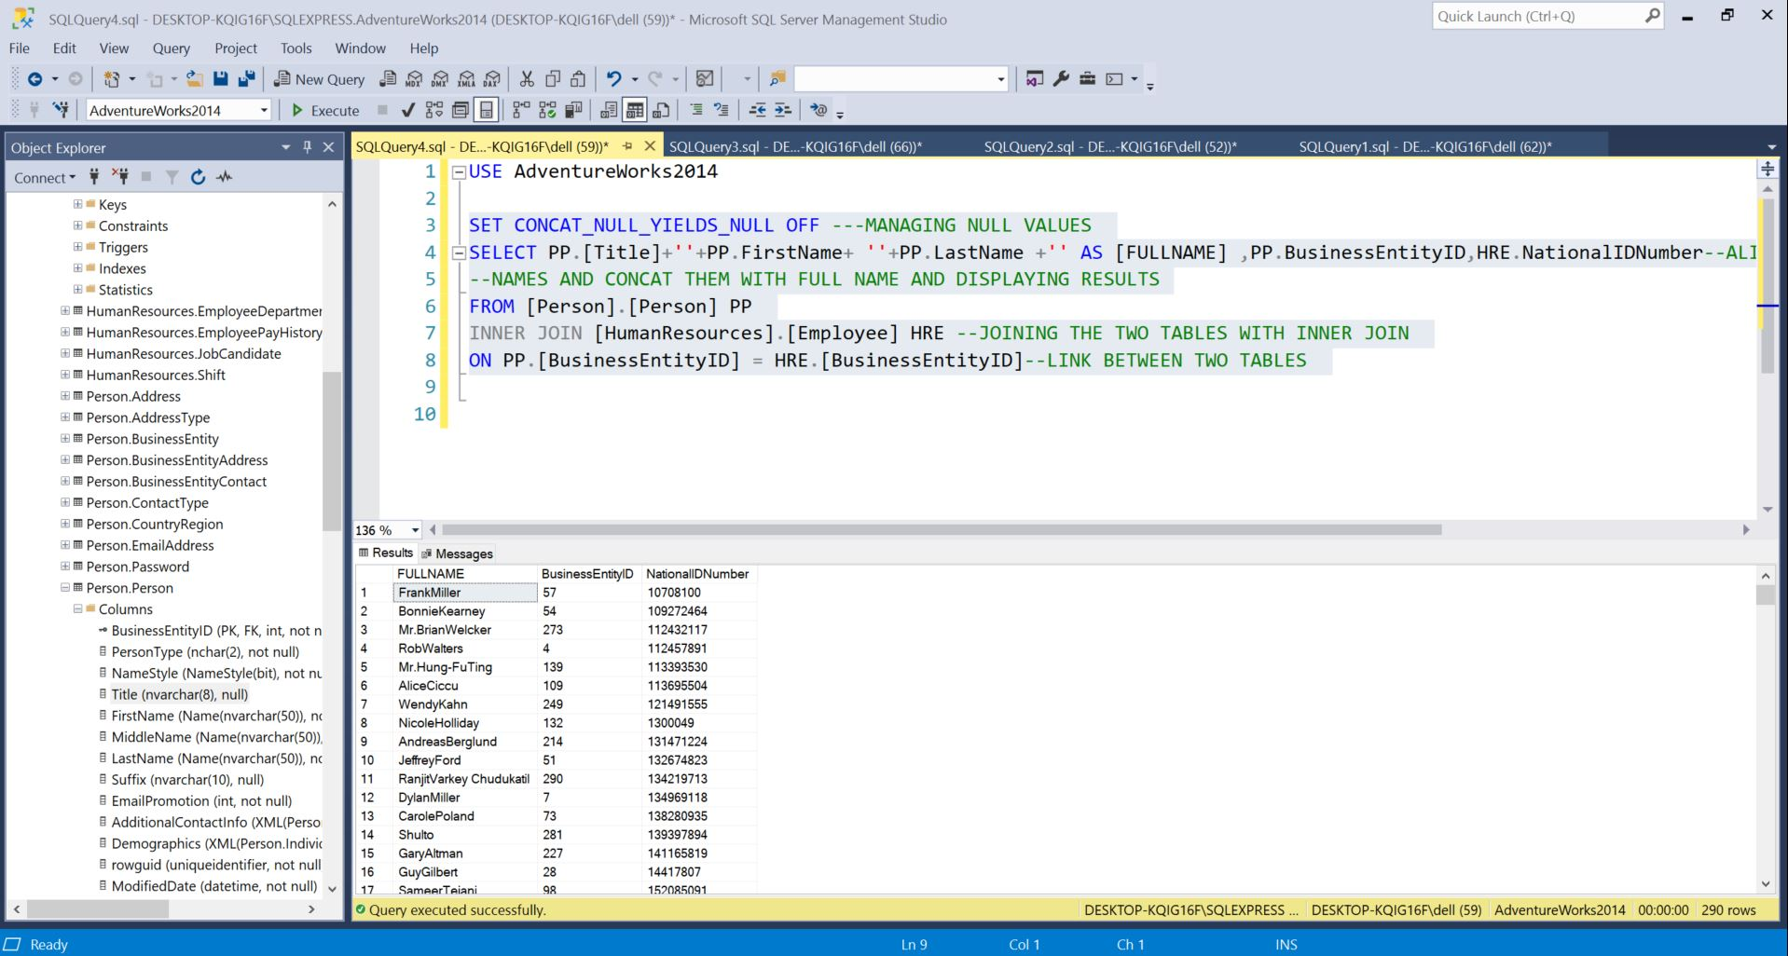

**QUESTION 4**

**Q.5 Write a query to display all customers with the same territory.**

**Query:**

SELECT C1.[CustomerID],C1.[TerritoryID],C2.CustomerID,C2.TerritoryID--displaing results

FROM [Sales].[Customer] C1

LEFT JOIN [Sales].[Customer] C2--joining the tables

ON C1.TerritoryID = C2.TerritoryID --link to joing

WHERE C1.CustomerID != C2.CustomerID --condition for no duplicate values

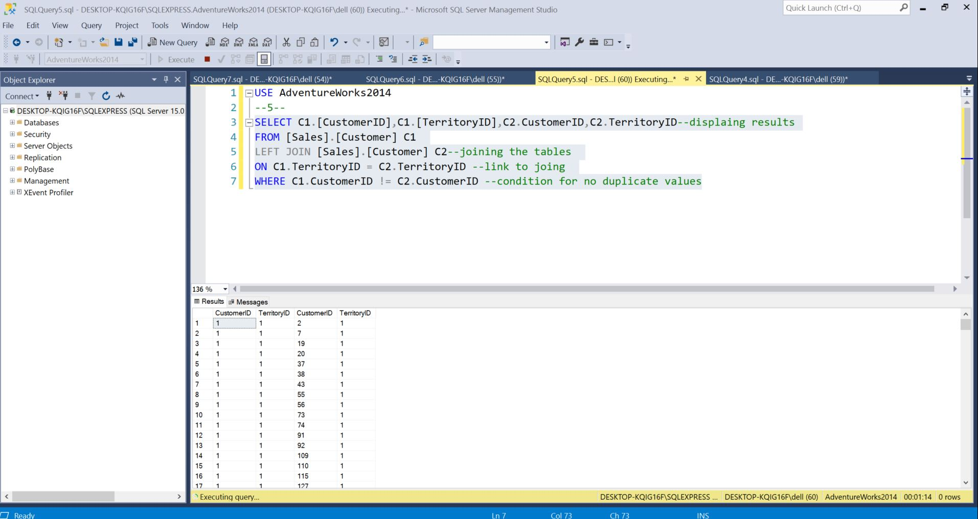

**QUESTION 5**

**Q.6. Write a query to display all data about the sales person with the highest sales last year.**

**Query:**

SELECT * -- Select all columns

FROM Sales.SalesPerson -- From the Table SalesPerson

WHERE SalesLastYear = (SELECT MAX(SalesLastYear)-- The maximum sales of the sales person

FROM Sales.SalesPerson) -- From the table

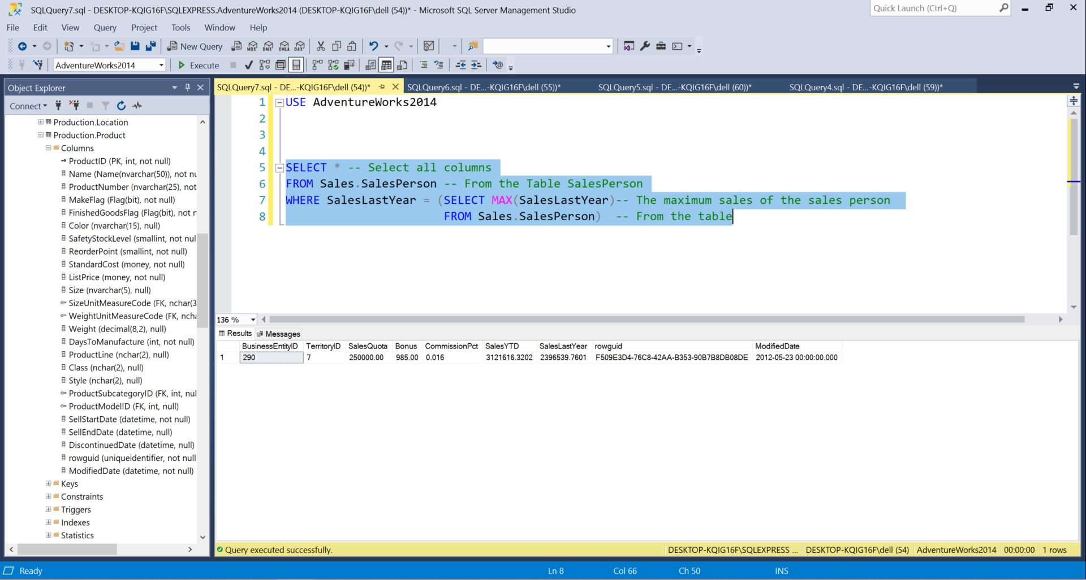

**QUESTION 6**

Q.7 **Write a query to list the name and list price of products having a price greater than average product price. **Use subquery to answer the question.**

**Query:**

SELECT DISTINCT [Name],[ListPrice] --DISLPAYING RESULT

FROM [Production].[Product] --

where ListPrice > (SELECT AVG(ListPrice) ---USING SUBQUERY AND CALCULATING AVERAGE

FROM [Production].[Product])---FROM TABLE

